**DBS311 Assignment#1**

**Group Members:**

**-Ali Riza Sevgili (135200228-Team Leader)**

**-Dragomira Velkova Veleva(184787216)**

**-Mina Elahi(183771211)**

**Instructions:**

**Single document submission only -- SELECT statements + ALL Outputs in SQL developer as clear screenshots**

**Late penalty is 100%.**

**Group size: Ideally 3-4 persons in a group. You may work on the assignment alone, but the requirement does not change. Deadline will not be extended due to group issues. Please write full name and id of each group member. Missing name and id member will not be graded.**

1. Display the employee number, full employee name, job and hire date of all

employees hired in May or November of any year, with the most recently

hired employees displayed first. Also, exclude people hired in 1994 and

1995. Full name should be in the form *Lastname, Firstname* with an alias

called *Full Name.*

Hire date should point to the last day in May or November of that year (NOT to the exact day) and be in the form like shown below with the heading *Start Date*. Do NOT use LIKE operator.

You should display ONE row per output line by limiting the width of the *Full Name* to 25 characters. The output lines should look like this line:

174 Abel, Ellen SA_REP [May 31st of 1996]

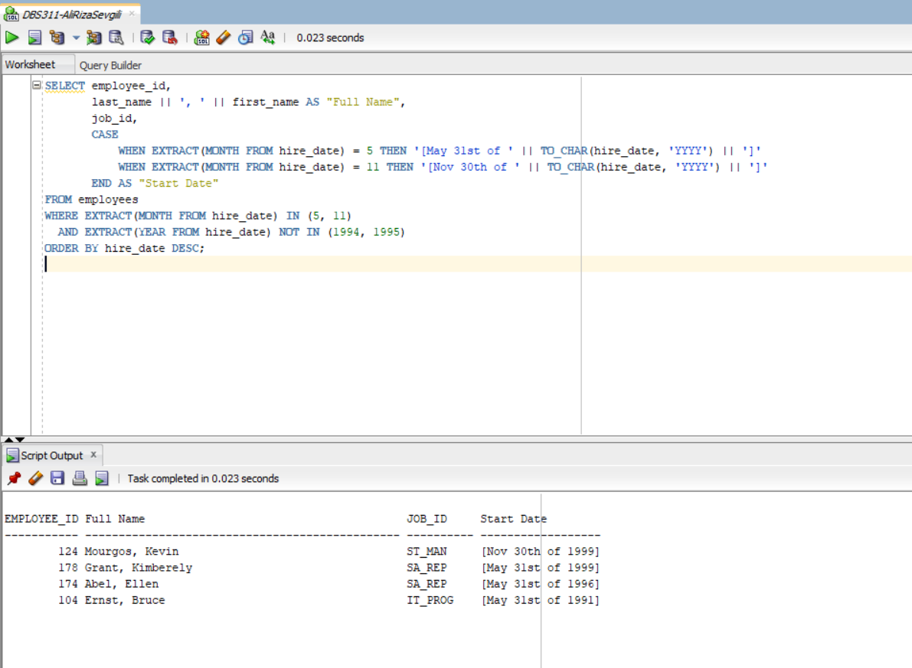

2. List the employee number, full name, job and the modified salary for all

employees whose monthly earning (without this increase) is outside the range $6,000 – $11,000 and who are employed as Vice Presidents or Managers (President is not counted here).

You should use Wild Card characters for this.

VP’s will get 30% and managers 20% salary increase.

Sort the output by the top salaries (before this increase) firstly.

Heading will be like *Employees with increased Pay*

The output lines should look like this sample line:

Emp# 124 : Kevin Mourgos is ST_MAN and will get a new salary of $6,960

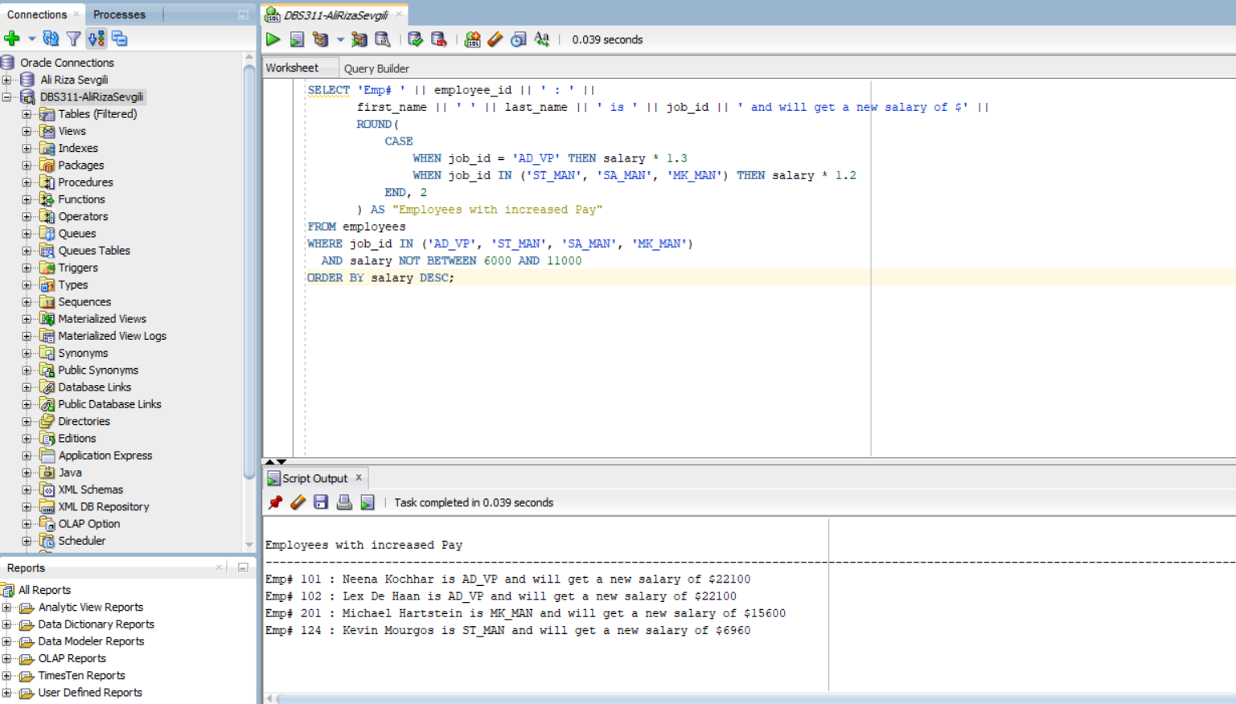

3. Display the employee last name, salary, job title and manager# of all

employees not earning a commission OR if they work in SALES department, but only if their total monthly salary with $1000 included bonus and commission (if earned) is greater than $15,000.

Let’s assume that all employees receive this bonus.

If an employee does not have a manager, then display the word NONE

instead. This column should have an alias *Manager#.*

Display the Total annual salary as well in the form of $135,600.00 with the

heading *Total Income*. Sort the result so that best paid employees are shown first. The output lines should look like this sample line:

De Haan 17000 AD_VP 100 $216,000.0

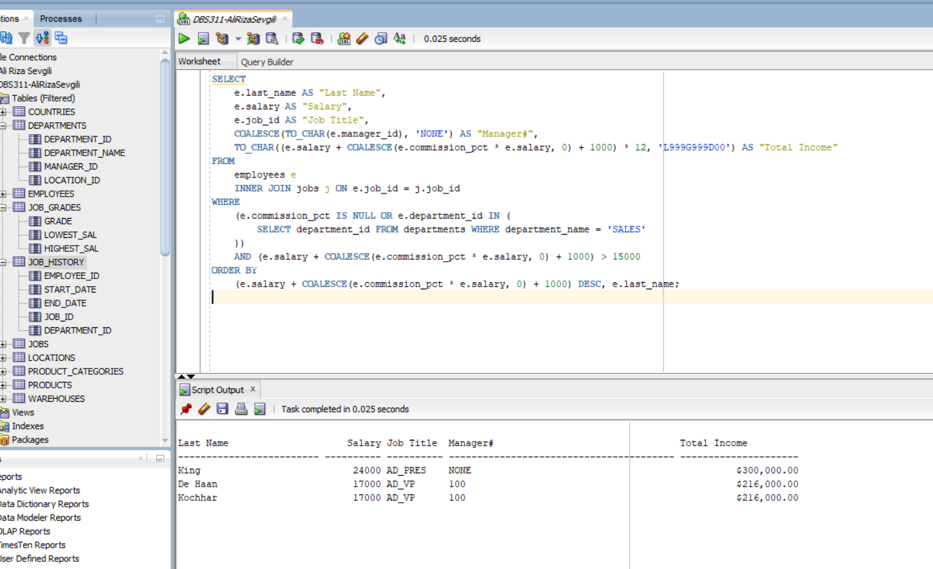

4. Display Department_id, Job_id and the Lowest salary for this combination under the alias *Lowest Dept/Job Pay*, but only if that Lowest Pay falls in the range $6000 - $18000.

Exclude people who work as some kind of *Representative* job from this query and departments IT and SALES as well.

Sort the output according to the Department_id and then by Job_id.

You MUST NOT use the Subquery method.

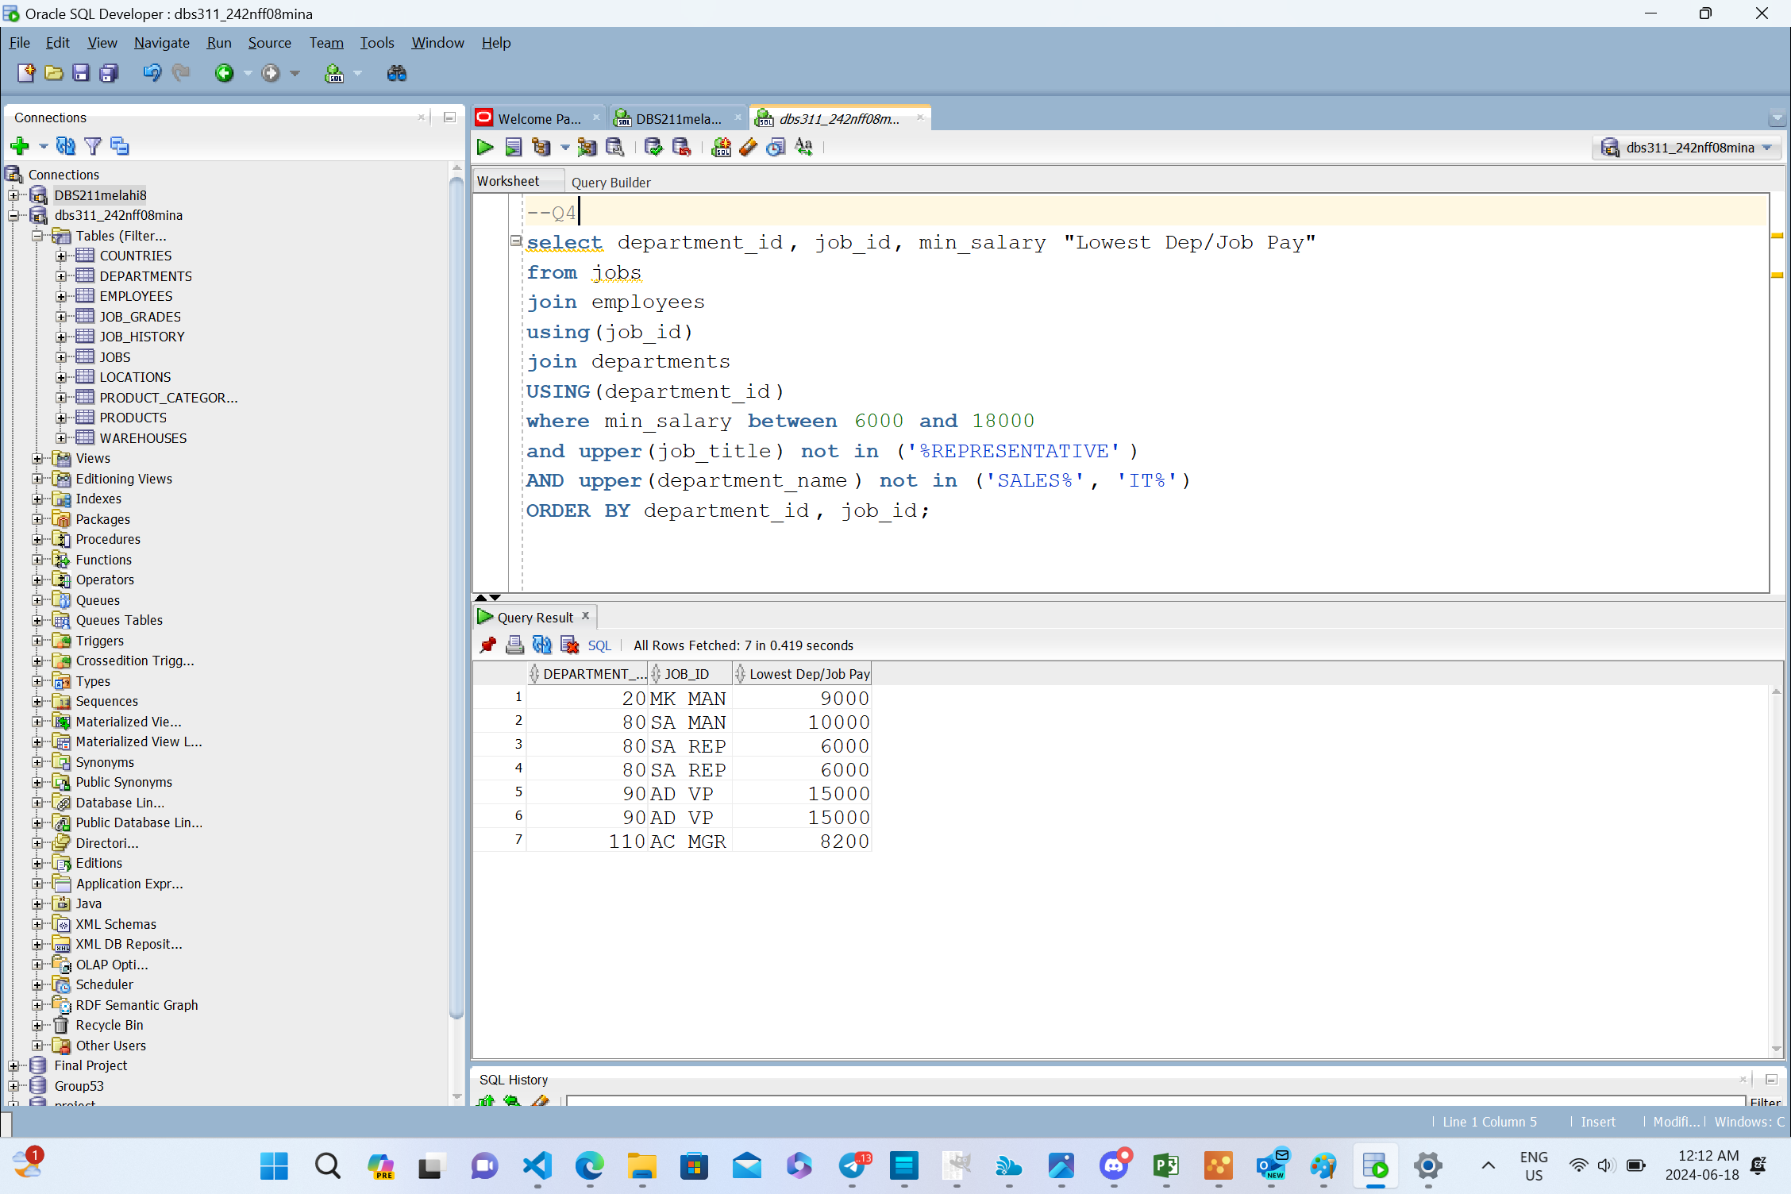

5. Display last_name, salary and job for all employees who earn more

than all lowest paid employees per department outside the US locations.

Exclude President and Vice Presidents from this query.

Sort the output by job title ascending.

You need to use a Subquery.

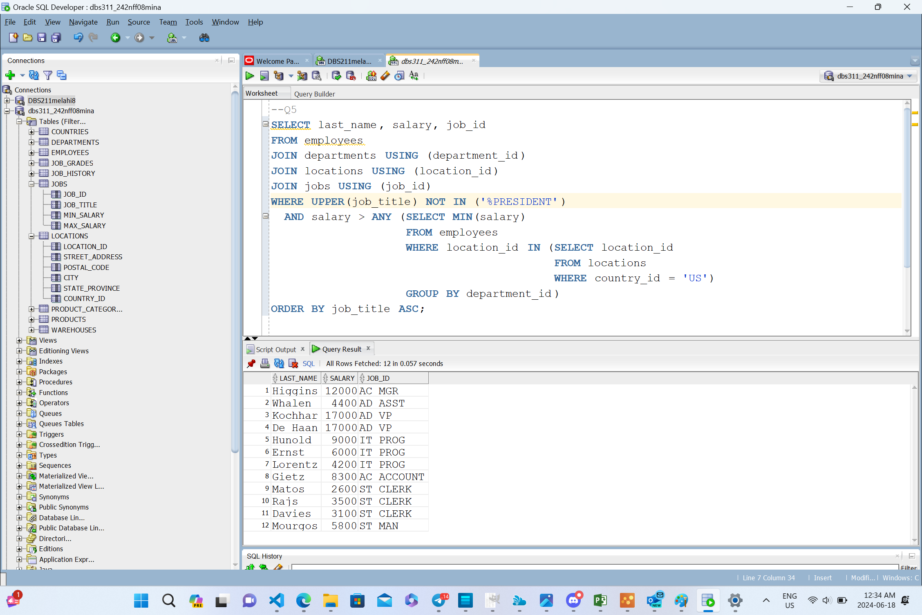

6. Who are the employees (show last_name, salary and job) who work either in IT or MARKETING department and earn more than the worst paid person in the ACCOUNTING department.

Sort the output by the last name alphabetically.

You need to use ONLY the Subquery method (NO joins allowed).

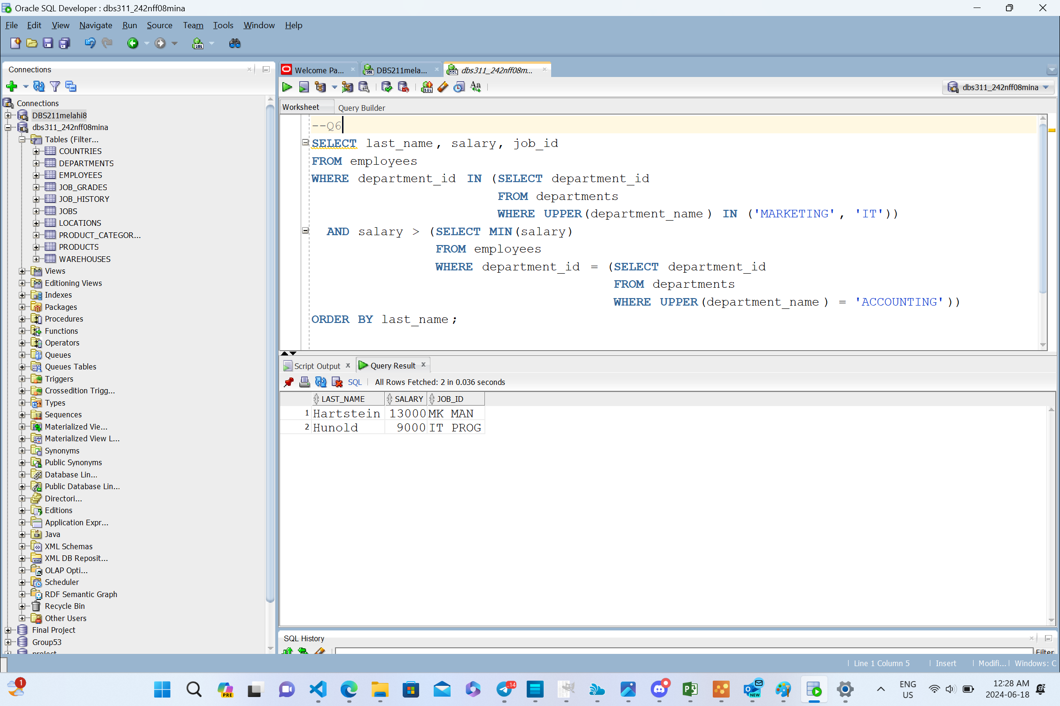

7. Display alphabetically the full name, job, salary (formatted as a currency

amount incl. thousand separator, but no decimals) and department number

for each employee who earns less than the best paid unionized employee

(i.e. not the president nor any manager nor any VP), and who work in either SALES or MARKETING department.

Full name should be displayed as *Firstname Lastname* and should have the heading *Employee.* Salary should be left-padded with the **&** symbol till the width of 10 characters. It should have an alias *Salary.*

You should display ONE row per output line by limiting the width of the

*Employee* to 25 characters.

The output lines should look like this sample line:

Jonathon Taylor SA_REP &&&& $8,600 80

8. “Tricky One”

Display department name, city and number of different

jobs in each department. If city is null, you should print *Not Assigned Yet.*

This column should have alias *City.*

Column that shows # of different jobs in a department should have the

heading *# of Jobs*

You should display ONE row per output line by limiting the width of the

*City* to 25 characters.

You need to show complete situation from the EMPLOYEE point of view,

meaning include also employees who work for NO department (but do NOT display empty departments) and from the CITY point of view meaning you need to display all cities without departments as well.

You need to use Join method.

